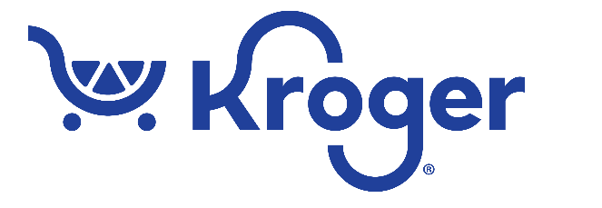

News Release:
Kroger Reveals the Favorite Easter Candy
Among Local Customers
- Retailer identifies the area’s top-selling candies and
debuts exclusive Peeps® flavor
[Indianapolis, IN. – March 21, 2024] – Kroger Central Division revealed the area’s favorite candies as Easter approaches.

Kroger customers are choosing Reese’s Peanut Butter Eggs more than any other variety of candy during this holiday season. Other seasonal favorites complete the list.

Candy fans will also find a brand-new Peeps® flavor, Sour Strawberry, available exclusively at Kroger.

“No one has better taste in candy than Hoosiers during the Easter season,” said Eric Halvorson, Manager of Corporate Affairs, Kroger Central Division.

Kroger’s Top-Selling Easter Candy:

- Reese’s Peanut Butter Eggs

- Cadbury Mini Eggs

- Lindt Milk Chocolate Bunny

- M&M’s

- Cadbury Crème Eggs

“No matter how you choose to celebrate, Kroger has every bunny covered with affordable holiday meal staples, everyday low prices and savings on candy and gifts to make the day extra hoppy.” (There had to be puns, you know.)

###

About Kroger Central Division:
Kroger Central Division operates food stores, pharmacies and fuel centers in Indiana, Illinois, Missouri, and Ohio. We are dedicated to Kroger’s Purpose: to Feed the Human Spirit™ and to create #ZeroHungerZeroWaste communities by 2025.
Kroger Contact:
Media: Eric Halvorson, 317-579-8222 or eric.halvorson@kroger.com

